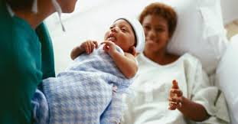

PRAF 2.0 NurtureOhio Interface:
Medicaid Provider User Guide

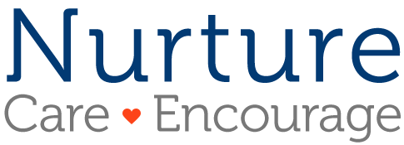
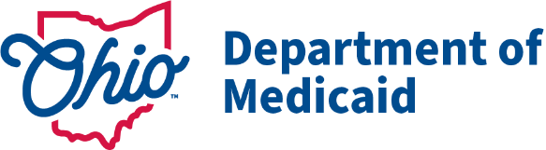

Contents
Welcome New Users! 4
What is NurtureOhio? 4
NurtureOhio Features 4
Who Should Use NurtureOhio? 5
What is a PRAF? 5
What is an ROP? 5
Benefits of Using NurtureOhio to Submit Perinatal Notifications 5
User Types 6
How to Obtain Access to NurtureOhio 6
Prenatal Visit Agent Role Assignment 6
How to Log into NurtureOhio 7
New User Screen 8
Welcome Screen 9
Update User Information 9
How to Submit a Perinatal Risk Assessment Form (PRAF 2.0) 10
Confirm Practice Details 11
Adding Patient Information 12
Patient Validation 12
Provider Information 19
Patient Details 20
Patient Details, cont. 21
Risks and Referrals 22
Submit 24
Exporting PRAFs 25
How to Submit a Report of Pregnancy (ROP) 26
Confirm Practice Details 26
Add Patient Information 28
Patient Validation 28
Patient Validation Fields 28
ROP Form 33
Logging Out 36
Additional Information 37
Adding a Practice 37
Forgotten Username or Password 37
Help Desk and User Support 38
Help Form 38
I Have a Question about the PNM module, OH|ID, or Portal Password Support 39
Maintenance and System Outages 39
Appendix A: About NurtureOhio Features 40
Shareable Data Entry 40
One Time Data Entry of Practice and Provider Information 40
Same-Day Pregnancy Notification 40
Ability to Retrieve and Save Previously Entered Forms 41
Appendix B: Creating an OH|ID Account for PNM as a Provider Agent 42
Appendix C: Adding Agent Roles in PNM 44
Appendix D: Patient Form Error Messages/Transmission Statuses 46
Error Messages 46
Medicaid Transmission Statuses 46

Welcome New Users!
This guide will help you navigate the NurtureOhio website. Some of the key items provided are:
- Definitions of Perinatal Risk Assessment Form (PRAF 2.0) and Report of Pregnancy (ROP) related topics
- Step by step guidance on logging into the system
- Step by step guidance on submitting forms
- Features of NurtureOhio
- Help with troubleshooting
- Additional tips and resources

What is NurtureOhio?
NurtureOhio was developed in 2016, in partnership with the Ohio Perinatal Quality Collaborative, the Ohio Department of Health, 23 Medicaid Maternal and Fetal Medicine providers, and the five Medicaid Managed Care Organizations (MCOs) to standardize pregnancy notification and decrease the risk of preterm birth. Through continued spread, the project has since grown beyond the progesterone quality improvement project, and the NurtureOhio web-based system has become the Ohio Department of Medicaid’s preferred method for notification of pregnancy and needs during the postpartum period for all Medicaid-insured individuals across the state.

NurtureOhio is a web-based system that stores and shares information about perinatal risks and health-related social needs (HRSNs). This information is collected using the electronic Perinatal Risk Assessment Form (PRAF 2.0) and the Report of Pregnancy (ROP). Once a user submits either the PRAF 2.0 or ROP in NurtureOhio, the data is seamlessly transmitted to the Ohio Department of Medicaid’s eligibility system to ensure maintenance of Medicaid coverage, the Ohio Department of Health (ODH) for connection to the Women and Infant Nutrition Program (WIC), the Ohio Department of Children and Youth (DCY) for evidence-based Home Visiting, and the individual’s Managed Care Organization (MCO) and County Department of Jobs and Family Services (CDJFS) for resources and identified needs.

NurtureOhio is used to notify the Ohio Department of Medicaid and key stakeholders of pregnancy and the start of the postpartum period for all Medicaid-insured individuals for eligibility maintenance and care coordination. Through the PRAF and ROP, NurtureOhio transmits the minimum information needed about Medicaid individuals’ pregnancy and postpartum information to the appropriate stakeholders to ensure their needs are met.

NurtureOhio Features
- Shareable Data Entry
- One Time Data Entry of Practice and Provider Information
- Same-Day Pregnancy Notification
- Ability to Retrieve and Save Previously Entered Forms
- Ability to Export CSV files of submitted PRAFs

More information on these features can be found in Appendix A.

Who Should Use NurtureOhio?
- Clinical obstetrical providers should submit a Perinatal Risk Assessment Form (PRAF 2.0) on behalf of their patients.
- Clinical non-obstetrical providers, such as primary care providers, emergency department providers, local health department clinics, etc. (when able to positively confirm the individual’s pregnancy) should submit a Report of Pregnancy (ROP).
- CBOs and MCOs should also submit an ROP when notified of a pregnancy.
- Managed Care Organizations (MCOs) and County Department of Jobs and Family Services (CDJFS) to assist with resource connection.

What is a PRAF?
The Perinatal Risk Assessment Form (PRAF) is intended for submission at the patient’s first prenatal visit and the start of the postpartum period. PRAF replaced the ODM 03535 form and is a shorter version. The PRAF should be submitted during the first prenatal appointment, at the start of the postpartum period, and whenever there is a change in the patient’s social or medical risk factors or needs.

What is an ROP?
The purpose of the Report of Pregnancy (ROP) form is to capture a Medicaid individual’s pregnancy as soon as possible to assist with eligibility and care coordination. ROPs are intended for submission at the first report of pregnancy. The ROP can be submitted by non-obstetrical Medicaid providers, Medicaid MCOs, and CBOs. For example, if a patient is at an annual well visit with their primary care doctor and reports being pregnant, an ROP should be submitted on behalf of the patient. An additional example would be if a patient is seen at the emergency department or a local health department and is determined to be pregnant, an ROP should be submitted on behalf of the patient. The goal is to connect the individual to obstetrical care and other services and ensure coverage throughout pregnancy and the postpartum period to optimize health care access and health outcomes for the mother and infant. Again, the ROP is only intended for submission by non-obstetrical Medicaid providers, Medicaid MCOs, Doulas, and CBOs.
Please note: If your practice provides obstetrical services, the PRAF should be submitted on behalf of your patients. If your practice does not provide obstetrical services, ROP forms should be submitted on behalf of your patients. These forms should only be completed for Medicaid recipients.

Benefits of Using NurtureOhio to Submit Perinatal Notifications
- Updating pregnancy details in Ohio’s Medicaid eligibility system to prevent loss of Medicaid coverage during pregnancy and postpartum period
- MCO notification of potential members for care coordination and incentive programs to provide support and resources during pregnancy and the postpartum period
- Enables County Department of Job and Family Services (CDJFS) users to verify that pregnancies are added to the Ohio Benefits system and coordinate care via referrals
- Timely referrals to the Ohio Department of Health’s Special Supplemental Nutrition Program for Women, Infants, and Children (WIC)
- Referrals to DCYs Home Visiting Central Intake platform

User Types
Users are classified into five different user types which impact what views they have access to and how they enter information in the NurtureOhio system. For the purposes of NurtureOhio, ODM defines the following user types:

- Practice Users are users associated with a practice that provides obstetric services
- MCO are users affiliated with ODM’s contracted MCO
- Non-OBGYN are users associated with a clinical practice that does not provide obstetric services but can confirm an individual’s pregnancy via a positive pregnancy screening such as primary care, emergency department, urgent care, community health centers, community clinics, etc., and as those users identified by ODM as doulas.
- Secondary MCOs are managed care entity (MCE) users that do not oversee the primary medical coordination for the individual but could identify a pregnant member, such as Aetna OhioRISE
- OEI Community Based Organizations and CBO Lead Entities are users from organizations identified by the Ohio Department of Medicaid as Ohio Equity Institute Lead Infant Mortality Entities and their corresponding Community Based Organizations

How to Obtain Access to NurtureOhio
All Provider users of the NurtureOhio site must be associated with an enrolled Medicaid provider. If a practice site is not associated with an enrolled Medicaid provider, they will need to complete the enrollment process. Enrollment applications must be submitted using Ohio Medicaid's Provider Network Management (PNM) module. Anyone accessing the Provider Network Management (PNM) module will need an OH|ID to log in.

Practice and Non-OBGYN users will need to use their OH|ID to access the NurtureOhio system.
Instructions for setting up an OH|ID personal online user account can be found in Appendix B.

Prenatal Visit Agent Role Assignment
Once an OH|ID is obtained, the provider administrator must assign the user the “Prenatal Visit” to the provider agent role in the PNM for users who will need to submit PRAFs. Instructions for the assignment of roles are found in Appendix C.

How to Log into NurtureOhio
To access the NurtureOhio website, visit: https://www.nurtureohio.medicaid.ohio.gov

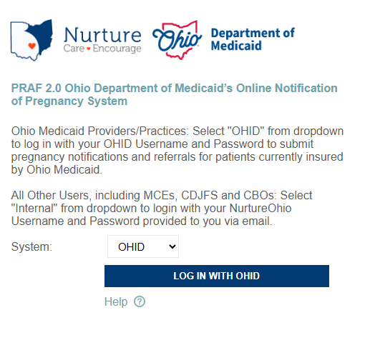

Ohio Medicaid Provider users: Select "OH|ID" from the dropdown to log in with your OH|ID Username and Password to submit pregnancy notifications and referrals for patients currently insured by Ohio Medicaid. Click “LOG IN WITH OH|ID”
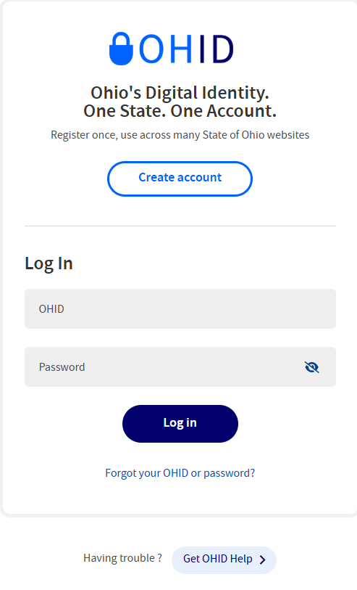

New User Screen
- After logging in for the first time, submitters will be taken to the New User Profile Setup screen.
- Some of the user information is pre-populated from OH|ID and the PNM
- Complete and review editable information and hit “Save and Begin”

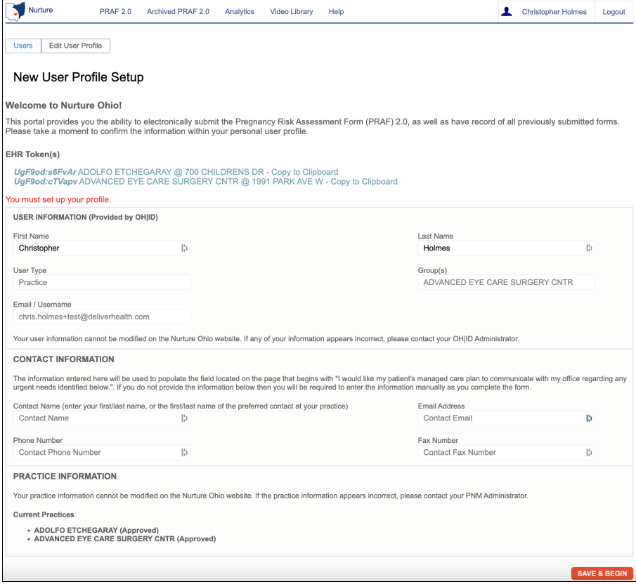

Welcome Screen

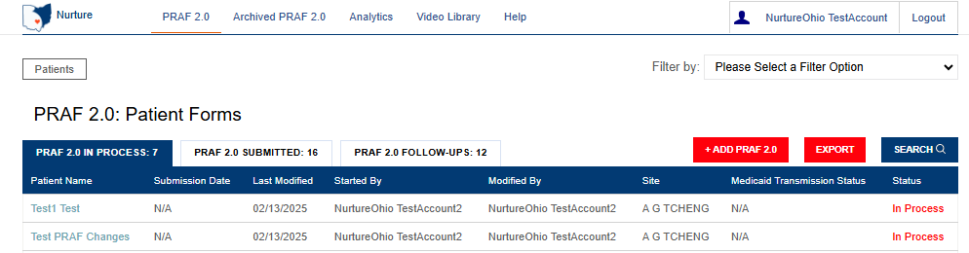

Update User Information
After clicking on the User ID on the Welcome Screen, users can review information about their user account. On this screen, users can:
  - Review user information
    - Note: If first name, last name, and email address need to be updated, update your information in OH|ID and the information will be synced to NurtureOhio automatically.
  - Add Contact information to populate the urgent need portion of the form
  - Review current practices
  - Return to the Welcome Screen after saving by clicking on “PRAF 2.0 or ROP” at the top of the screen
Please Note: Some information associated with your User ID will be inserted automatically. You will not be able to edit this information. If a user needs to update, add, or delete practice information, the organization’s PNM administrator will need to make this change within the PNM system.

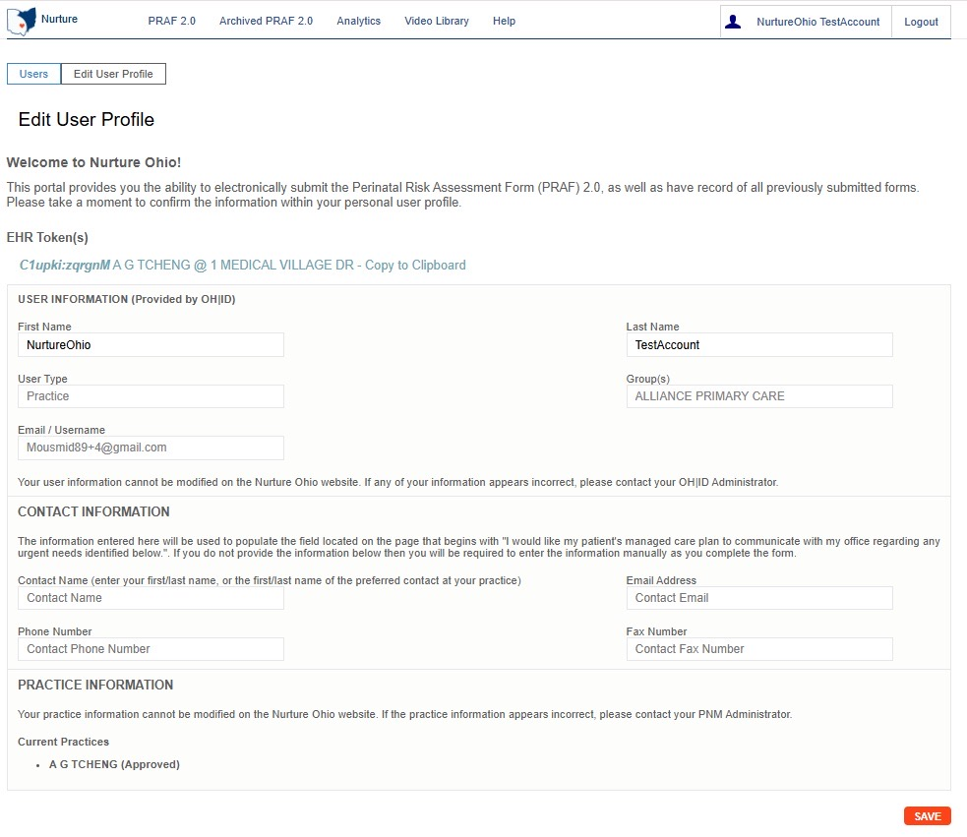

Please Note: Be sure to click the “Save” button at the bottom on this screen to save any changes you make on this screen, or they will be lost. Clicking the save button will return you to the Welcome Screen.

How to Submit a Perinatal Risk Assessment Form (PRAF 2.0)
After clicking on the “+ ADD PRAF 2.0” button on the Welcome Screen, users can enter information into the PRAF form.
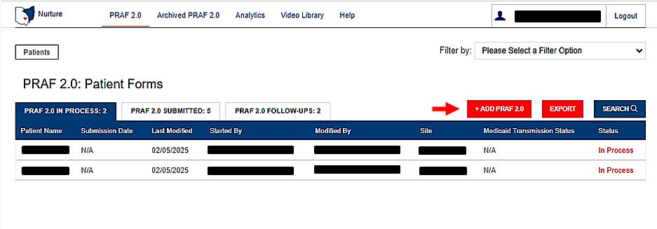

Confirm Practice Details
  - Select practice information.
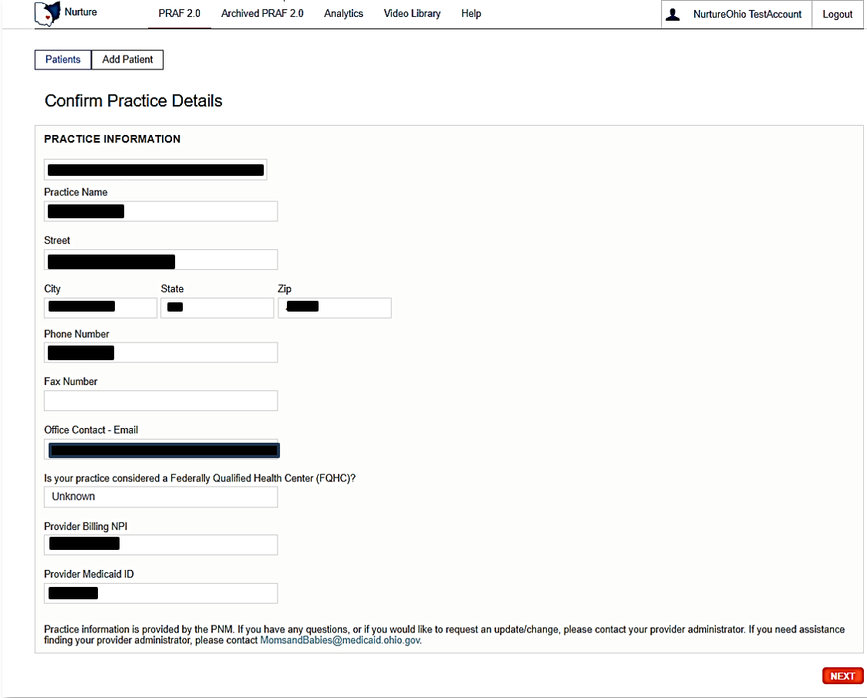
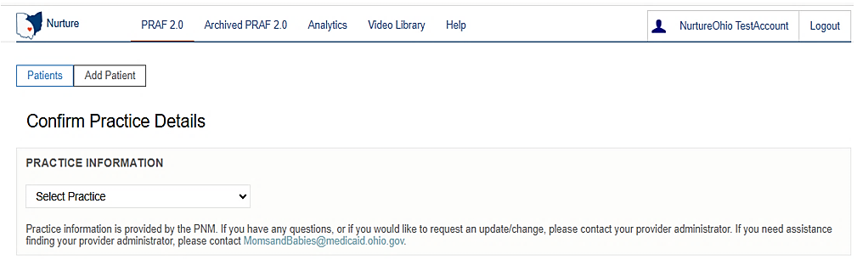
  - If you have multiple associated practices, this is where you will select the practice for which you are entering the PRAF.

Please Note: Practice information is provided by the PNM. If you have any questions, or if you would like to request update/change, please contact your provider administrator. If you need assistance finding your provider administrator, please contact MomsandBabies@medicaid.ohio.gov.

Adding Patient Information

Patient Validation
To improve data quality and avoid HIPAA concerns, a patient validation feature has been added to check that the information entered links to a Medicaid individual’s case. NurtureOhio takes the information entered and searches against Ohio Medicaid’s eligibility system. The user will receive feedback based on the data entered. If the information does not match, the user will have the opportunity to correct, re-validate, and submit. If the information still does not match after correcting the fields indicated, the user may continue without validation but verify the data after submission and resubmit. The user has up to 30 days to edit the form and resubmit. After 30 days, the user will not be able to edit a form and must submit a new form.
1. Complete the required fields:
  - Patient Medicaid ID (Patient MMIS ID) and/or Patient Social Security Number (9-Digit)
  - Patient First Name
  - Patient Last Name
  - Patient Date of Birth
  - Estimated Due Date and/or Date of Delivery

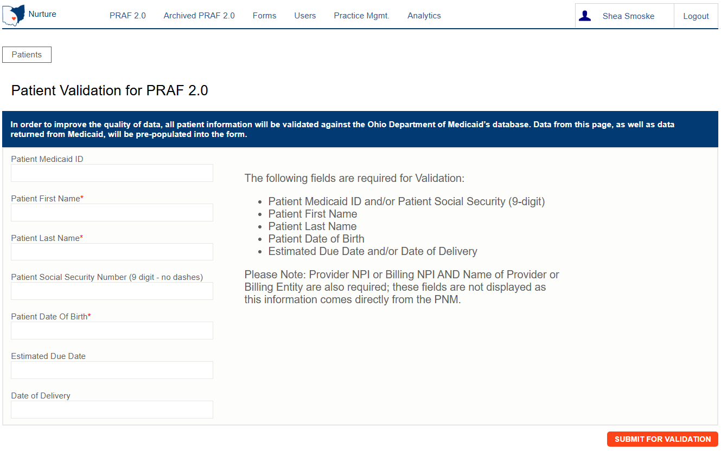


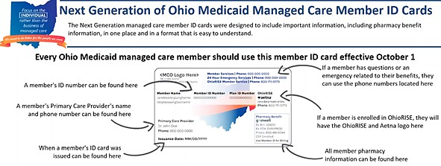
Please Note: The Patient's Medicaid ID location is shown on the Medicaid card below. For more information and to view the Medicaid ID on archived Medicaid cards, see Appendix A.

- Select Submit for Validation:

NurtureOhio will search the PRAF 2.0 system to ensure no other records from the last 30 days can be found in the system for that member.

The following notification will appear after you submit, select OK to continue:

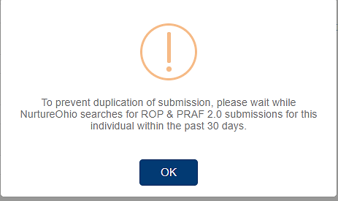

The following notification will appear when no matching PRAF 2.0 record is found, select OK to continue

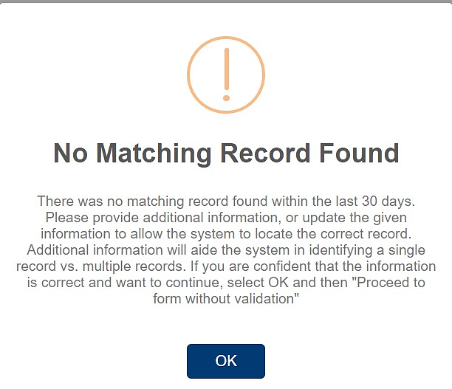

The following notification will appear when a matching record is found, select OK to continue:

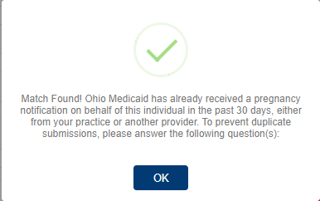

If a matching record is found, users must answer the following questions:
In the past 30 days, have there been changes to:
- The individual’s health?
- Social risk factors from the prior submission?
- Has there been changes to the individual’s pregnancy due date or number of fetuses?
  - If yes: the user may continue to complete a new form
  - If no: the user must open the previously completed form to edit with new information or the user can stop the submission

You will receive the following notification if you answer no to all questions, select OK to continue:

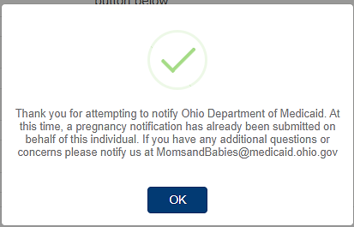

If there is a PRAF matching the individual’s information, but it was submitted by another provider, the following will appear:

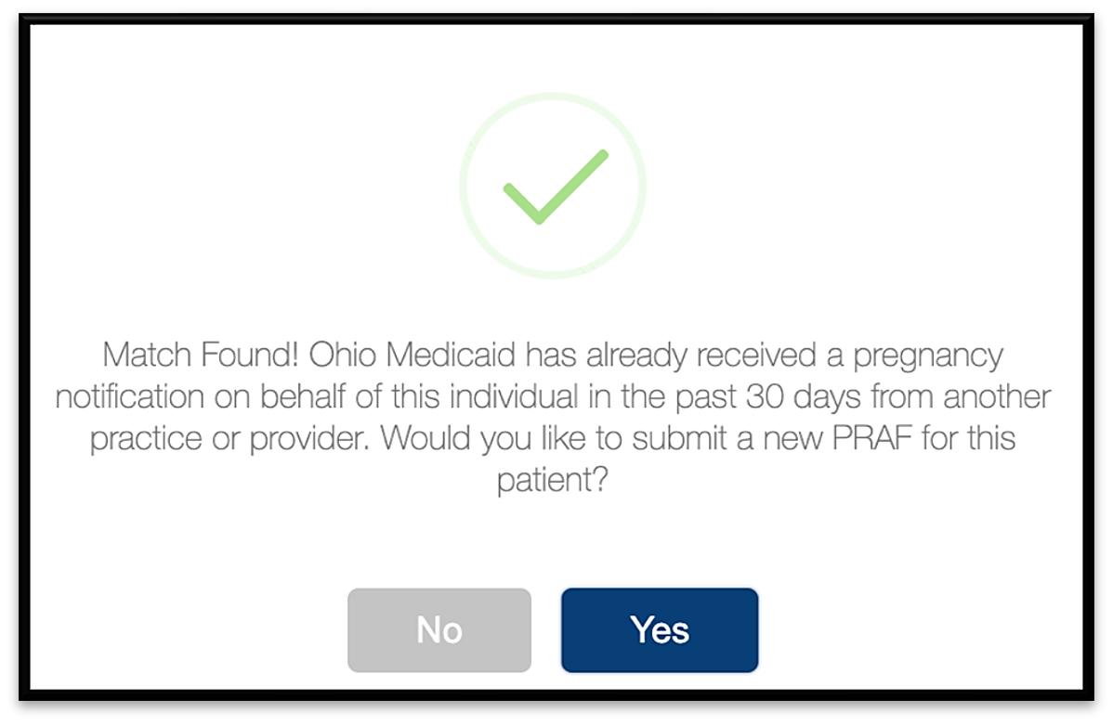
- Selecting “No” will stop the PRAF and send you back to the home page.
- Selecting “Yes” will create a new PRAF using your selected practice.

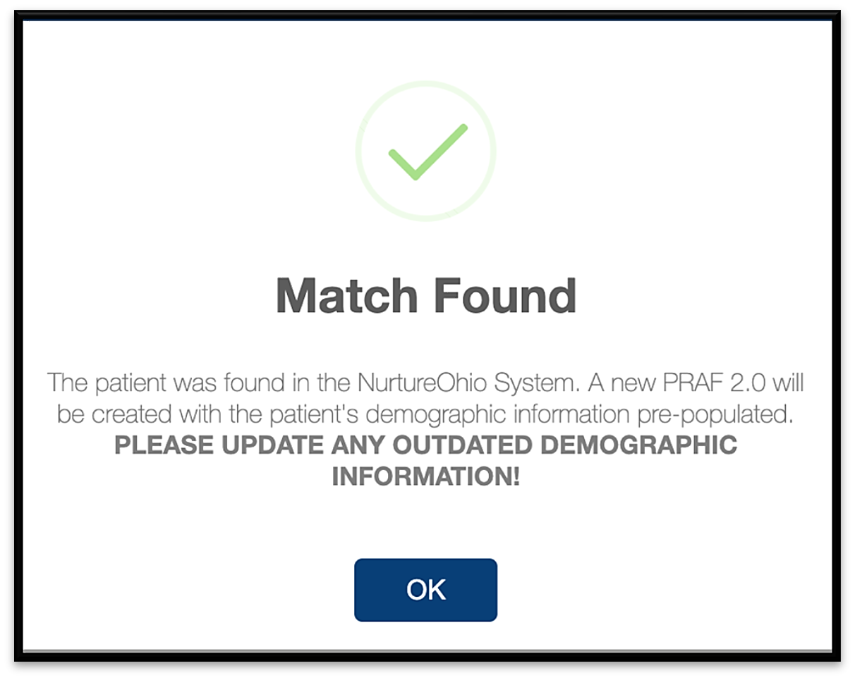
If there is a PRAF matching the individual’s information and was submitted more than 30 days and less than 9 months ago, you will see the following prompt, select OK to continue:

- The individual’s information from the previously submitted PRAF will be used to pre-populate the individual’s demographic information.
- This is still creating a new PRAF for the individual.

- NurtureOhio then checks with the Ohio Medicaid system to ensure the patient has a profile in the Medicaid system.

Means the information provided does not have a matching record in the Medicaid system

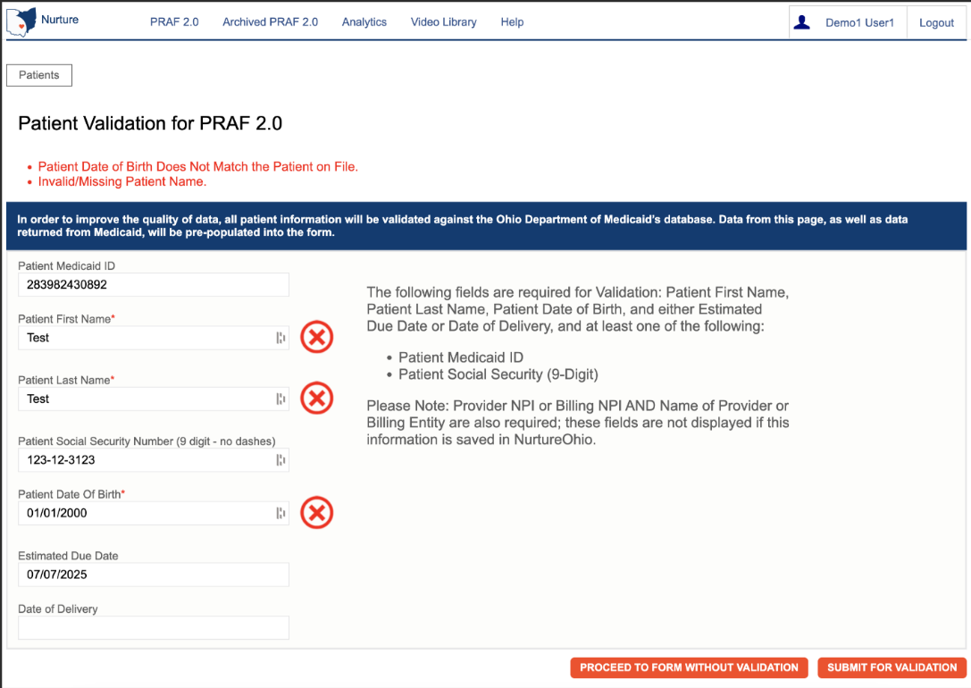

- There can be more than one error returned at once.
- Error messages will appear above the form.
- Possible error messages that you could see:
  - Patient Date of Birth Does Not Match the Patient on File.
  - Invalid/Missing Patient Medicaid ID.
  - Invalid/Missing Patient Name.
  - Patient Not Found
  - Must Provide Valid Patient Medicaid ID and/or Social Security Number.
  - Duplicate Patient ID Number.
  - Patient does not have active Medicaid coverage.
  - System is unable to respond, please contact the NurtureOhio Helpdesk.
    - This error also automatically sends an alert to NurtureOhio.

To proceed:
- The user must verify the patient’s information.
- Correct errors
- Resubmit for validation

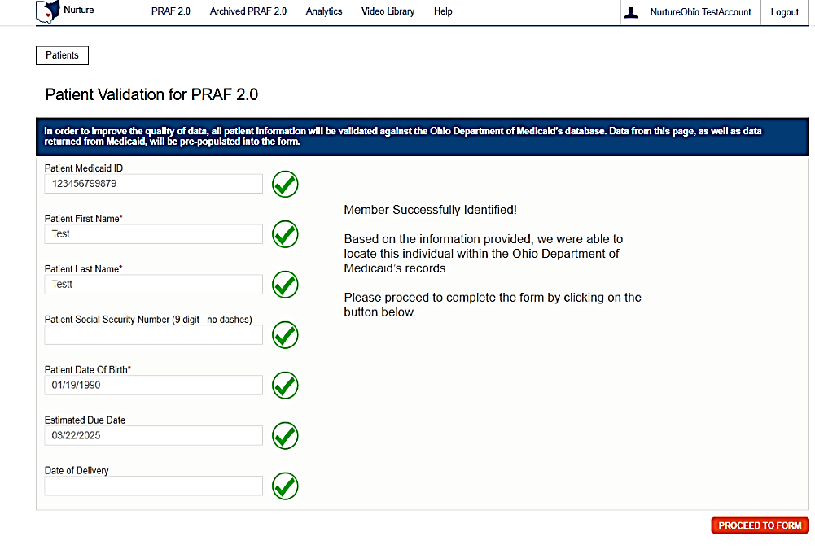
Means the information provided has a matching Medicaid record and the user may proceed to the form.

Please Note: The PRAF may be submitted without verifying eligibility with Medicaid by selecting “Proceed to form without verification”
- Risks of not verifying Medicaid eligibility:
  - No reimbursement for submission of PRAF
  - No follow-up of referrals
  - Potential HIPAA violation

Provider Information
All information on the following screen is automatically entered into the form based on the information submitted when creating a new practice except:
Date of Service- Date the perinatal appointment occurred
Provider Medicaid ID- This will be populated by the PNM association.
- NurtureOhio makes sure all required information is filled in before you are allowed to go on to the next page of the PRAF form
- All missing fields will be highlighted in RED.
- You can click “Save for Later” to save any information you’ve entered without completing the form or sending the information to the patient’s MCO.
- Patients saved for later will appear as “In Process” on the Welcome Screen.
- In process PRAFs will be saved for 30 days. If PRAFs are not completed within 30 days, they must be resubmitted.
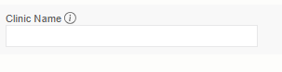
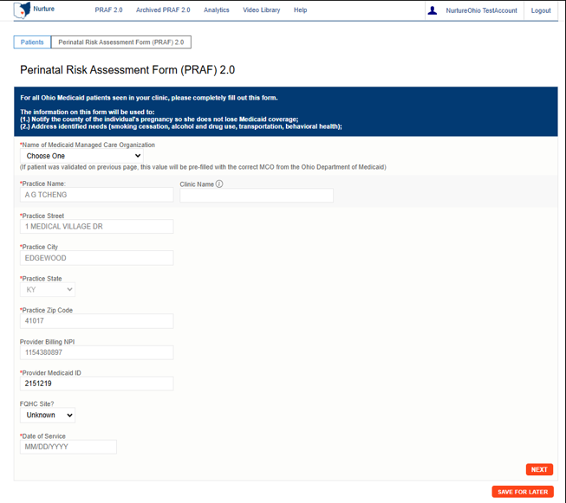
Note: Some questions have tooltips you can hover over and get more information about the question

Patient Details
To complete the patient details, you must complete either the Patient’s Medicaid ID or Social Security number. All details on this page must be completed except where “optional” is shown.

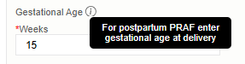
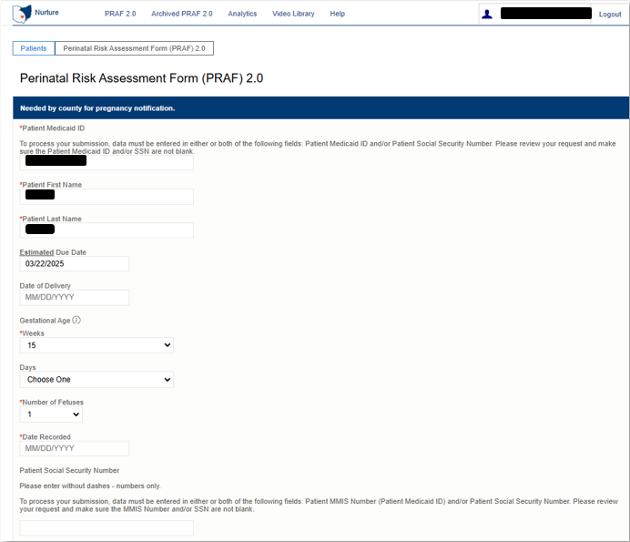
Please Note: When completing a postpartum PRAF, enter the Gestational Age at the time of delivery.

Patient Details, cont.
Once you have completed all required fields select “Next” to continue
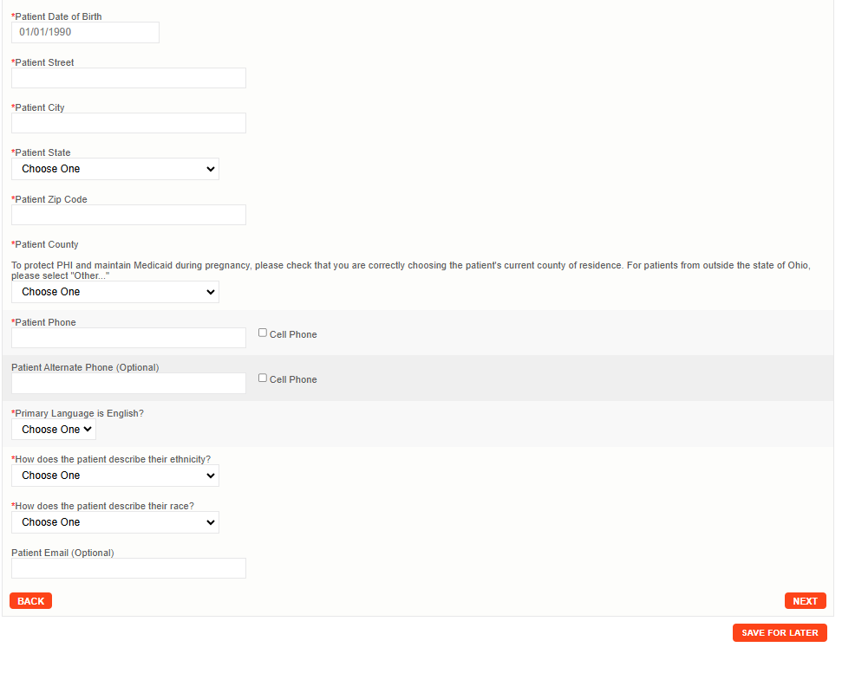

Risks and Referrals
This section is where risks and referrals are submitted to the patient’s Managed Care Organization and their County Department of Job and Family Services for follow-up.
- Complete Provider Contact Information
  - Choose if the patient would like the MCO to reach out to the practice for follow up about needs
  - Indicate a contact person at your site
  - Confirm Practice Phone and Email
  - Practice Fax (Optional)
- Perinatal Screeners
  - Select screening tool used. Screening tools are listed in the order of most used
  - Previously diagnosed checkbox. Check this box if the patient has an existing diagnosis
  - Enter the dates of referrals and treatments for identified diagnosis
  - Enter the date of initiating services for identified diagnosis

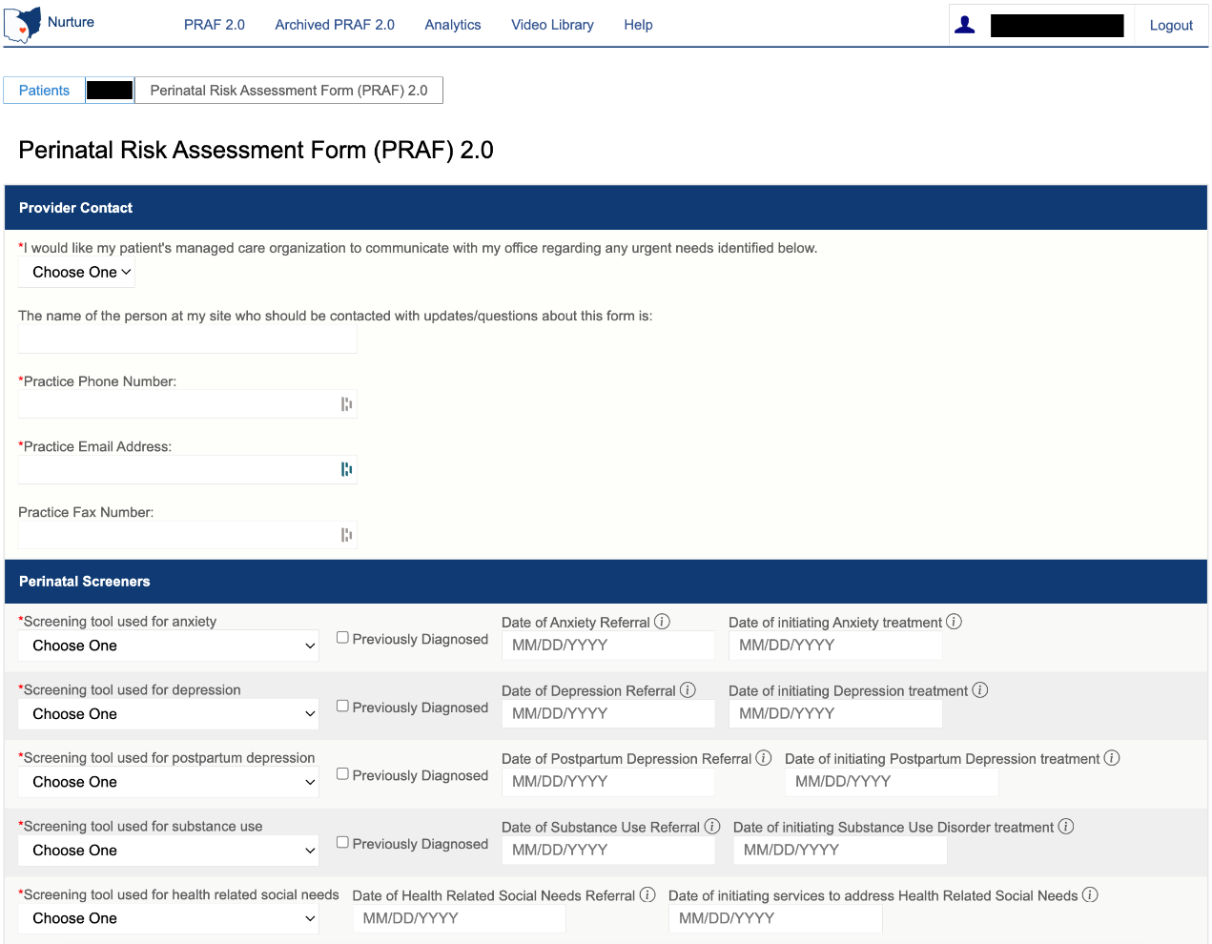

- Patient Risk Information
- Complete patient risk information checklist
- Make sure to check all that apply
    - Prior: If risk was identified in a prior pregnancy
    - Current: If risk is identified in the current pregnancy
    - Postpartum: If the risk is identified during the current postpartum period or was identified during a previous postpartum period
- Complete Managed Care Organization and County Department of Job and Family Services support checklist
- Check any area that your patient needs resources or assistance.
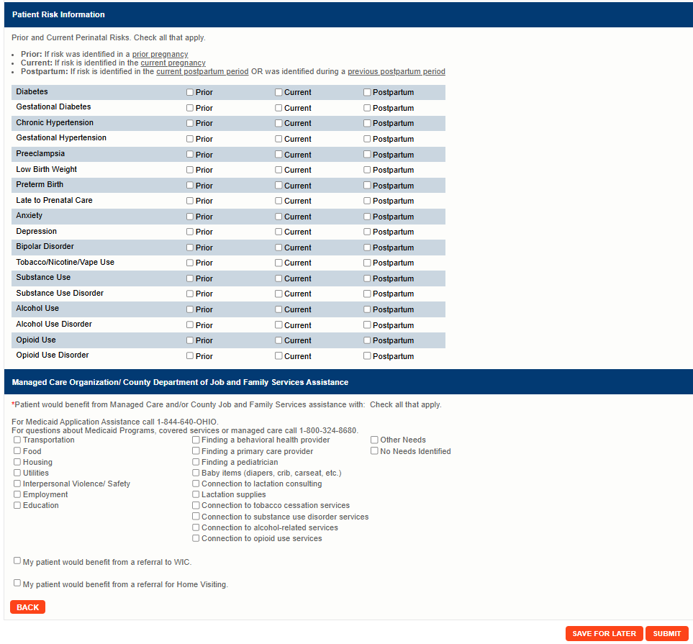

Checking “My patient would benefit from a referral for Home Visiting” will prompt you for permission to text the patient. You must ensure you have a cell phone listed for either the patient’s primary or alternate phone number.
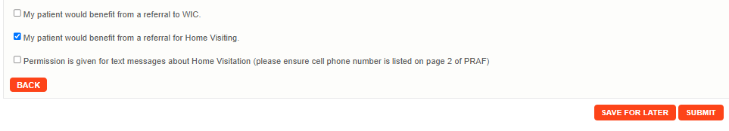

Submit
Once all required sections have been completed, click the “Submit” button.

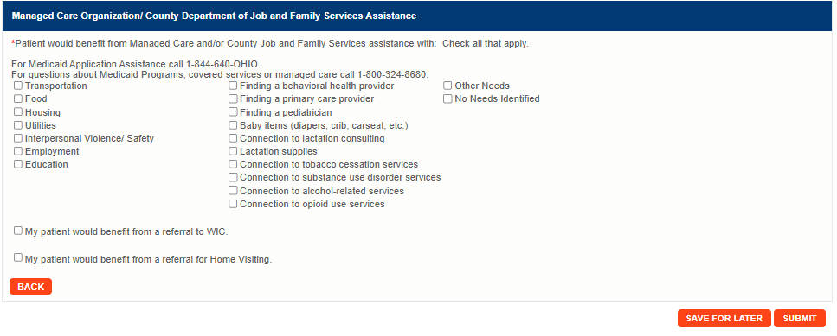

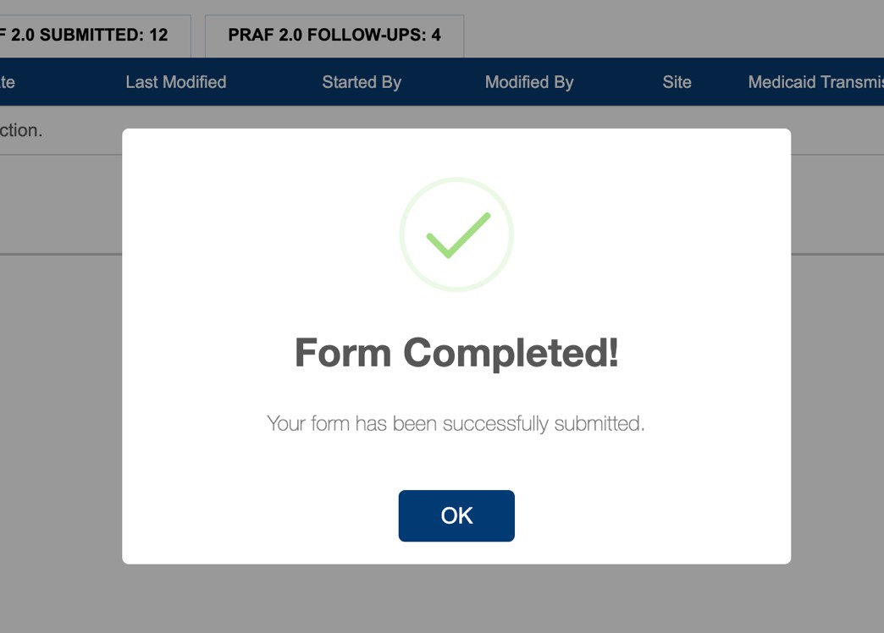
After the user submits the form, this message will appear. If all information on the form is completed correctly, the form will then be listed as “Pending” and then move to “Successfully Processed” under the Medicaid Transmission Status. For additional Transmission Status see Appendix D.

Exporting PRAFs
Users can export multiple PRAF forms to a CSV file by clicking the EXPORT button on the main forms screen.

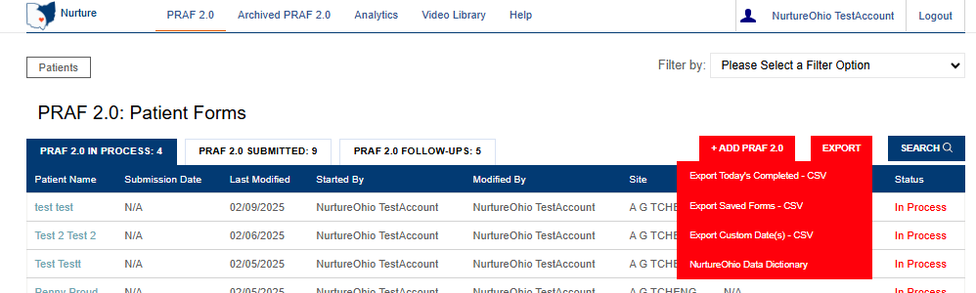

From the drop-down menu, users can choose to export “Todays Completed” forms, “Saved” forms, and “Custom Date(s) within a 30-day date range.”

There is also an option for exporting the NurtureOhio Data Dictionary. This document describes the details of the file output.

Once you select an option, the file will be exported and saved to the default download folder on your local machine.

How to Submit a Report of Pregnancy (ROP)
From the welcome page, the user will choose the “+ ADD ROP” button

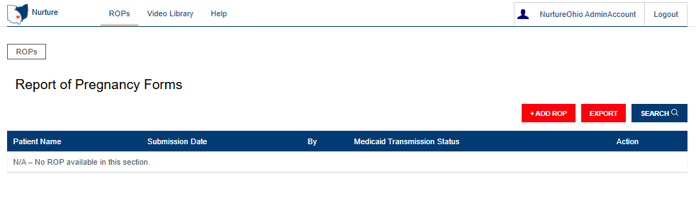

Confirm Practice Details
  - Select practice information.
  - If you have multiple associated practices, this is where you will select the practice for which you are entering the ROP

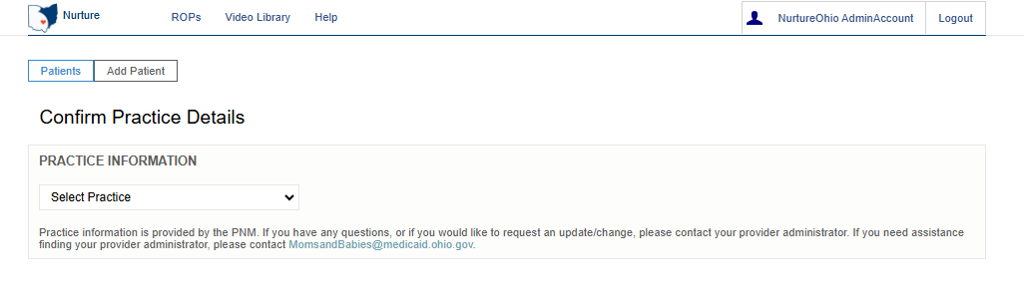

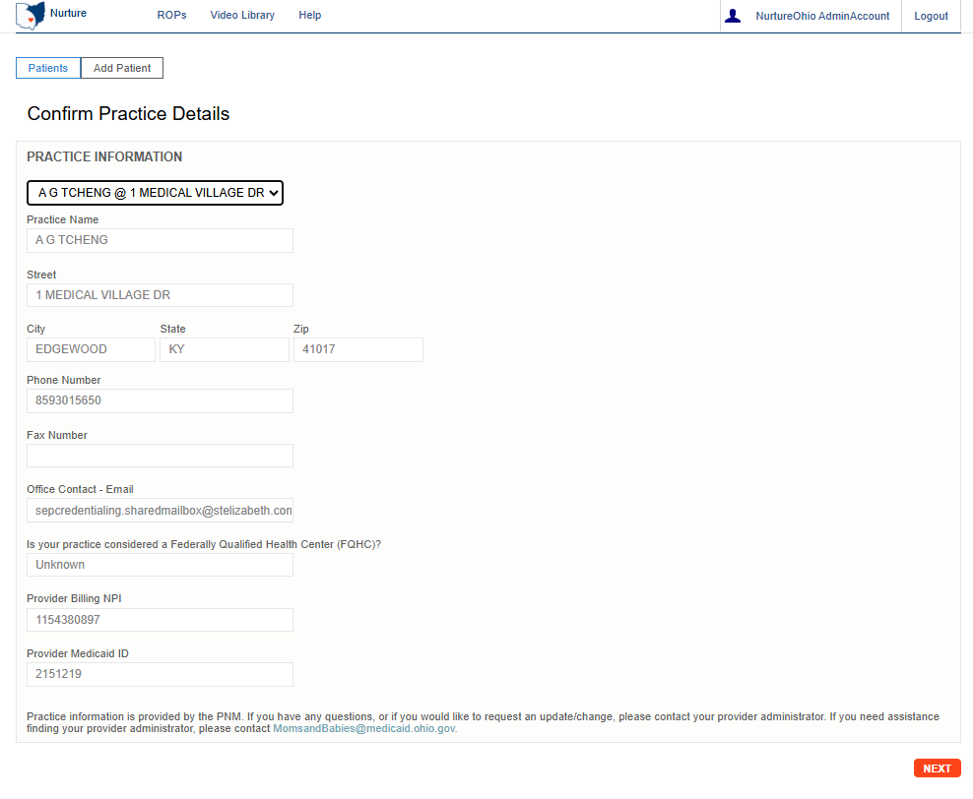

Add Patient Information

Patient Validation
To improve data quality and ensure HIPPA protections, a patient validation feature has been added to check that the information entered is linked to an individual’s Medicaid case. To complete this validation, NurtureOhio takes the information entered and searches against Ohio Medicaid’s eligibility system. The user will then receive feedback based on the data entered. If the information does not match, the user will have the opportunity to correct, re-validate, and resubmit. If the information still does not match after correcting the indicated fields, the user may continue without validation but will need to verify the data after submission, complete any necessary edits to the ROP, and then resubmit. The user has up to 30 days to edit the form and resubmit. After 30 days, the user cannot edit a form and must submit a new one.

Patient Validation Fields
- Complete the required fields:
  - Patient First Name
  - Patient Last Name
  - Patient DOB
  - Estimated Due Date
  - Patient Medicaid ID (MMIS number) or patient Social Security Number (9-Digit)
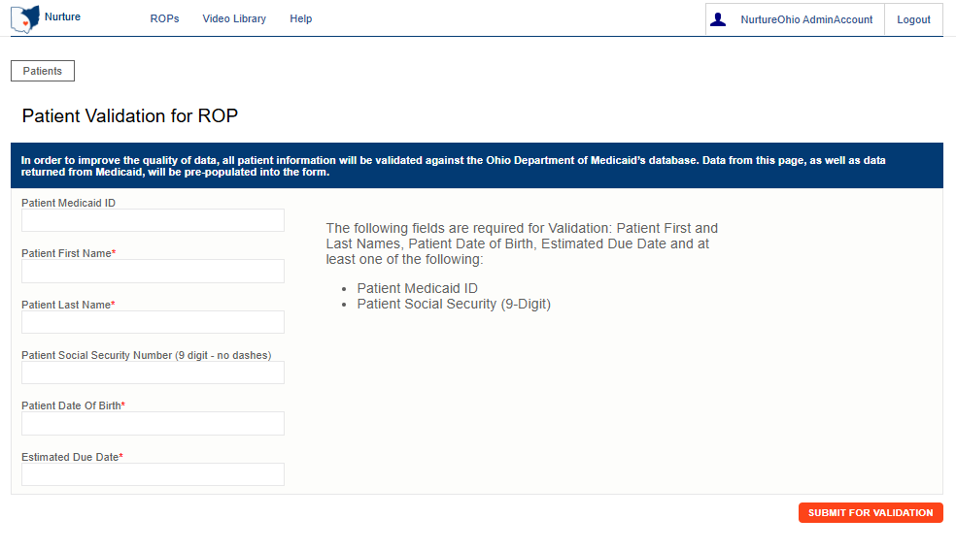

Note: The Patient's Medicaid ID may be found on the Medicaid card as shown in the graphic below. For more information and to view the Medicaid ID on archived Medicaid cards, see Appendix A.
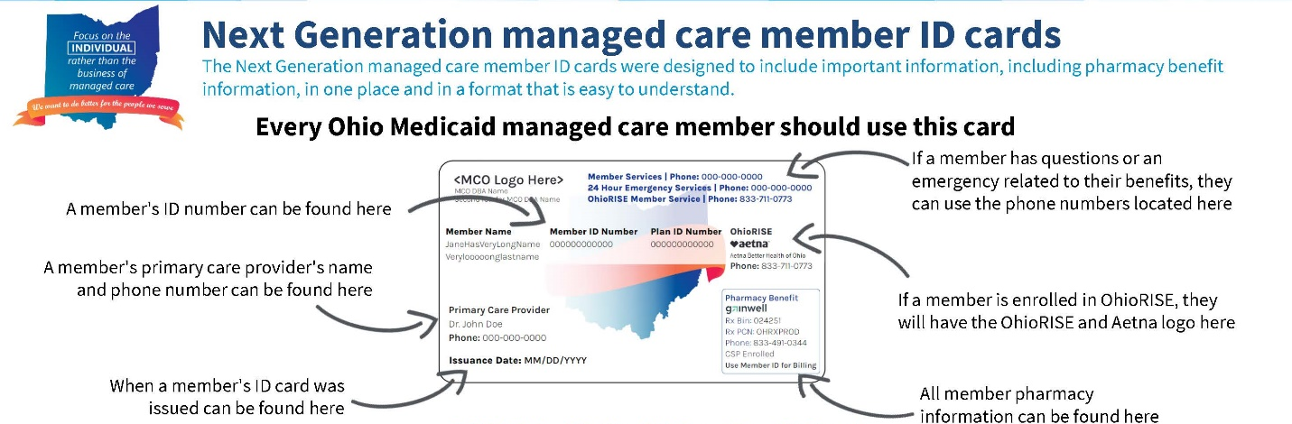

- Select Submit for Validation.
- NurtureOhio will search the ROP system to ensure no other records from the last 30 days can be found in the system for that member.

The following notification will appear, select OK to continue

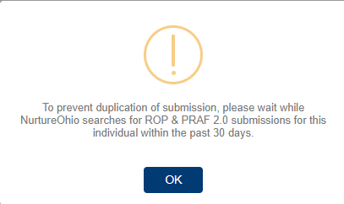

The following notification will appear when no matching ROP record is found:

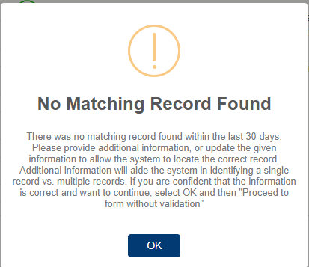

The following notification will appear when a matching record is found:

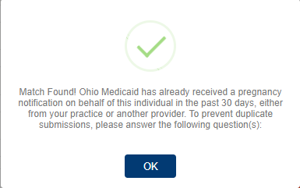

If a matching record is found, users must then answer the following questions:
In the past 30 days, have there been changes to:
- The individual’s health?
- Social risk factors from the prior submission?
- If yes: the user may continue to complete a new form
- If no: the user must open the previously completed form to edit with new information or the user can stop the submission


In the screenshot below the means that the information provided does not have a matching record in the Medicaid system and needs to be addressed.

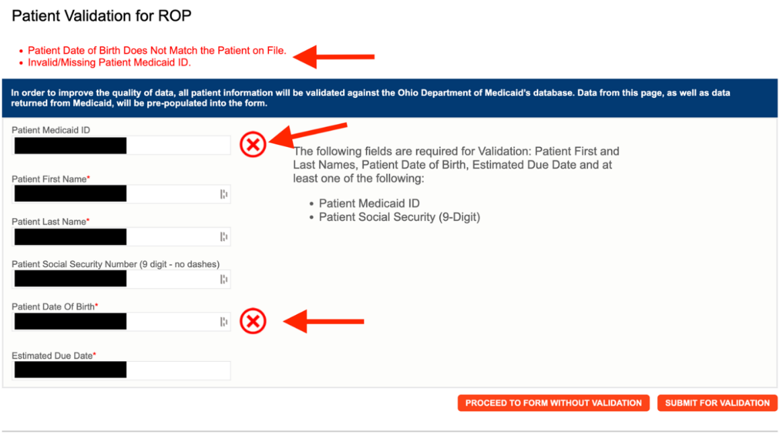

Note: There can be multiple errors returned at once and NurtureOhio does its best to identify the fields that need to be addressed. The common errors that can be returned are as follows:
- Invalid/Missing Date(s) of Service.
- Patient Date of Birth Does Not Match the Patient on File.
- Invalid/Missing Patient Medicaid ID.
- Invalid/Missing Patient Name.
- Patient Not Found.
- Duplicate Patient ID Number.
- Must Provide Valid Patient Medicaid ID and/or Social Security Number.
- Patient does not have active Medicaid coverage.
- System is unable to respond, please contact NurtureOhio Helpdesk (This error also sends an alert to NurtureOhio)

To proceed:
- The user must verify the patient’s information.
- Correct errors
- Resubmit for validation

- In the screenshot below, the means the information provided has a matching Medicaid record and the user may proceed to the form.

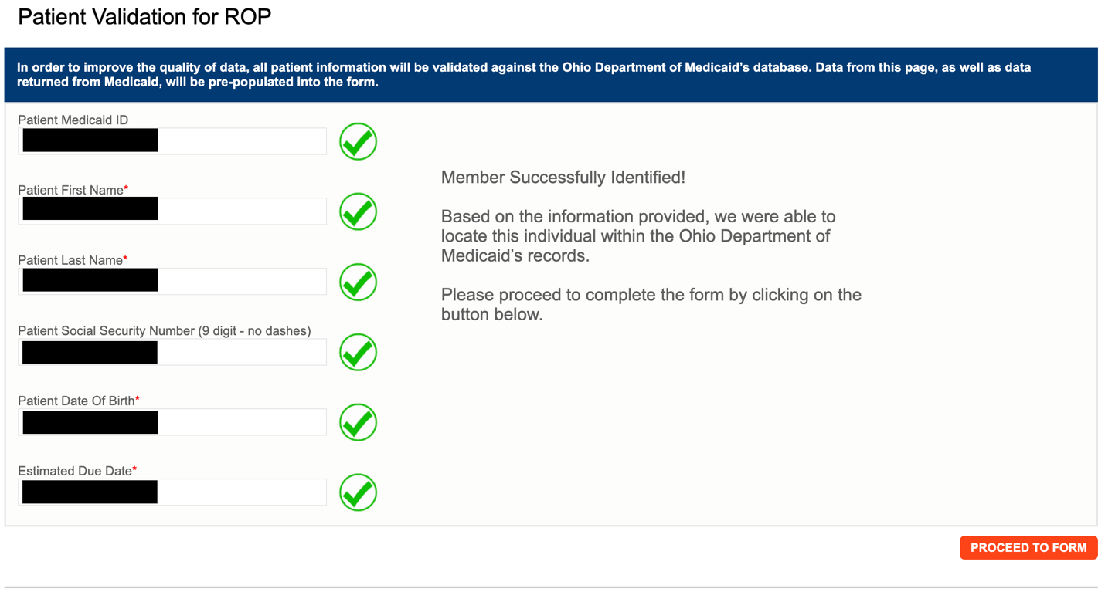
Please Note: The ROP may be submitted without verifying eligibility with Medicaid by selecting “Proceed to form without verification”
- Risks of not verifying Medicaid eligibility:
  - No reimbursement for submission of ROP
  - No follow-up of referrals
  - Potential HIPAA violation
  - System not notified of Medicaid eligibility

ROP Form
After clicking the “Proceed to Form” button, users are directed to the ROP Form (shown over the next few pages).
User must complete all required fields before selecting “submit” at the bottom of the form.

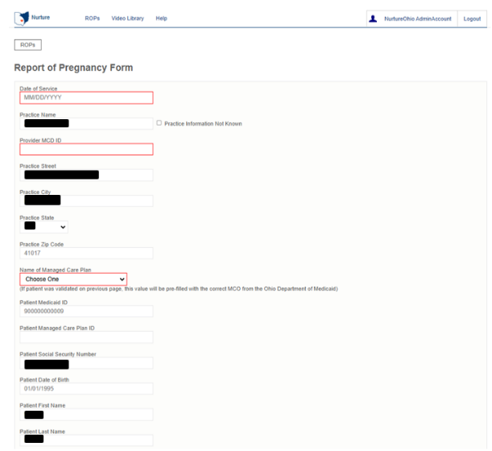

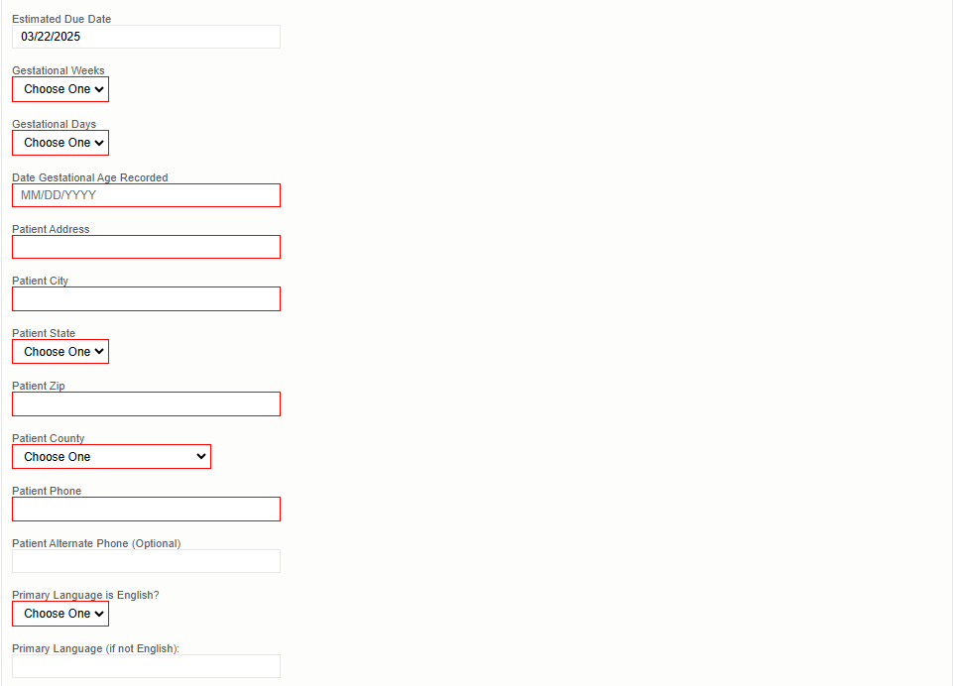

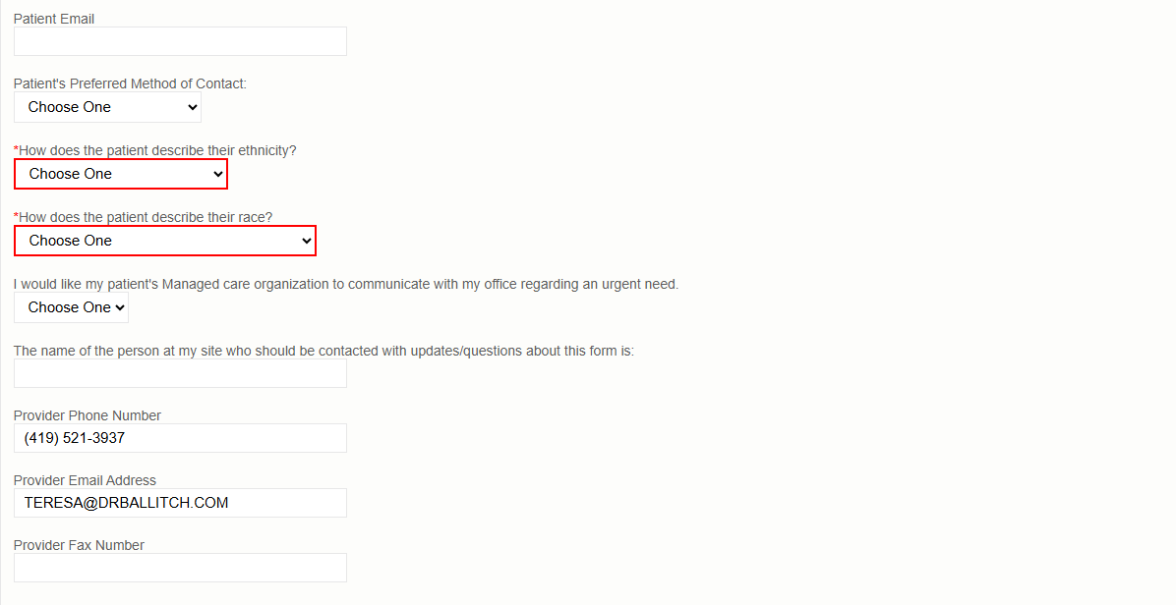

Referrals
This section is where submitters are asked to identify specific patient needs. Selecting a need will automatically trigger a referral to the patient’s Managed Care Organization (MCO) and County Department of Job and Family Services (CDJFS).

Patient need options include: Transportation; Food; Housing; Utilities; and Assistance finding an OB/GYN provider.
Submitters are prompted to indicate whether the patient:
- Assistance scheduling appointments (Yes/No)
- Patient has a prenatal appointment scheduled (Yes/No)

This information helps MCO and CDJFS staff provide appropriate support.

Submitters are prompted to indicate if the patient should be referred to WIC and/or Help Me Grow Home Visiting.
- Once the ROP is submitted, the Ohio Department of Health and the Department of Children and Youth are automatically notified if these resources are selected.

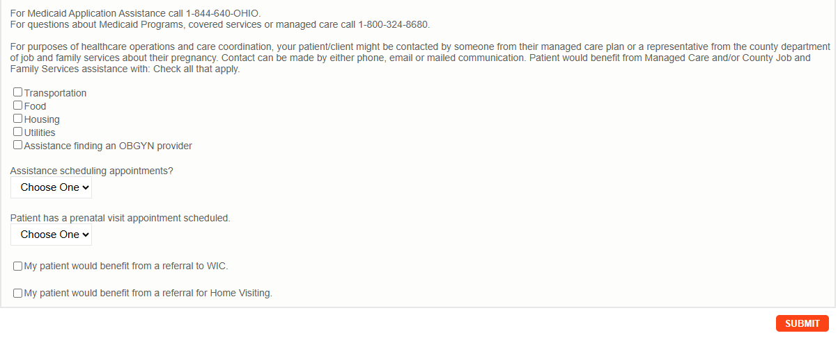

Checking “My patient would benefit from a referral for Home Visiting” will prompt you for permission to text the patient. You must ensure you have a cell phone listed for either the patient’s primary or alternate phone number is listed on the form.

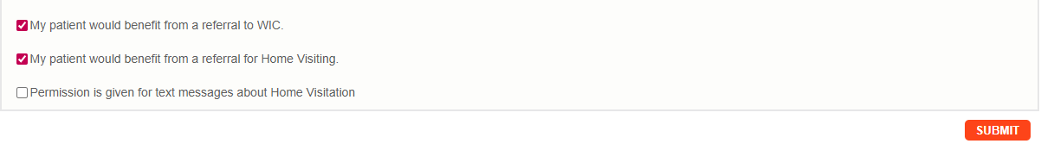

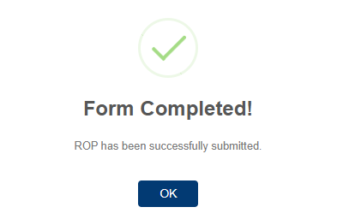

After the ROP form is submitted it will appear on the home page
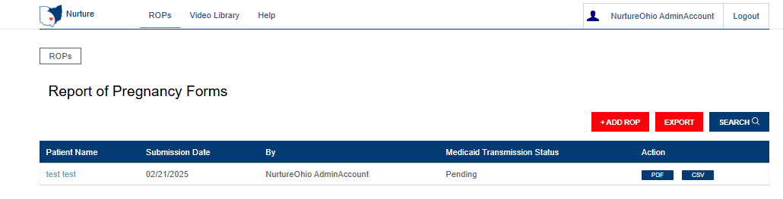

Logging Out
It is important to log out of the NurtureOhio and OH|ID systems when finished.
- Select “Logout” in the top right-hand corner of the screen.
This will direct the user to the OH|ID logout screen.
- Select “Log Out”


Additional Information

Adding a Practice
Practices cannot be added within NurtureOhio. All practices associated to your NurtureOhio account are from the PNM. If you need to add, remove, or update practices, you must do this in the PNM. See Appendix C.

Forgotten Username or Password
If you have forgotten your username or password or need help logging in, contact the Integrated Help Desk or go to https://ohid.ohio.gov/wps/portal/gov/ohid/login/ and follow the link “Forgot OH|ID?, Forgot password? or Get login help?”.

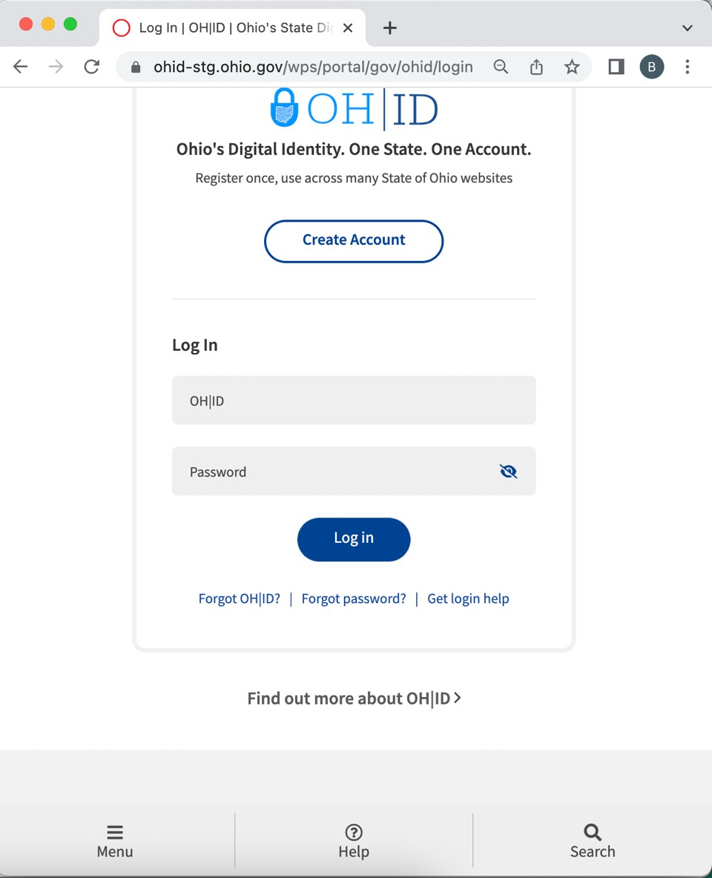

Help Desk and User Support
If you have any concerns or issues with the website, are unable to view fields or your practice did not populate please use the “HELP” button shown in the screen shot below.

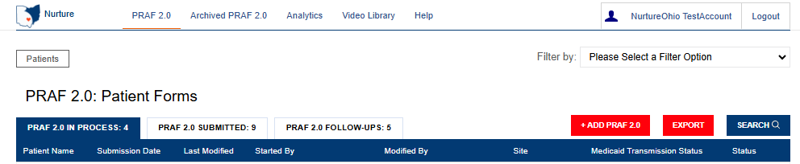

Help Form
- Provide a description of the issue
- Provide contact email
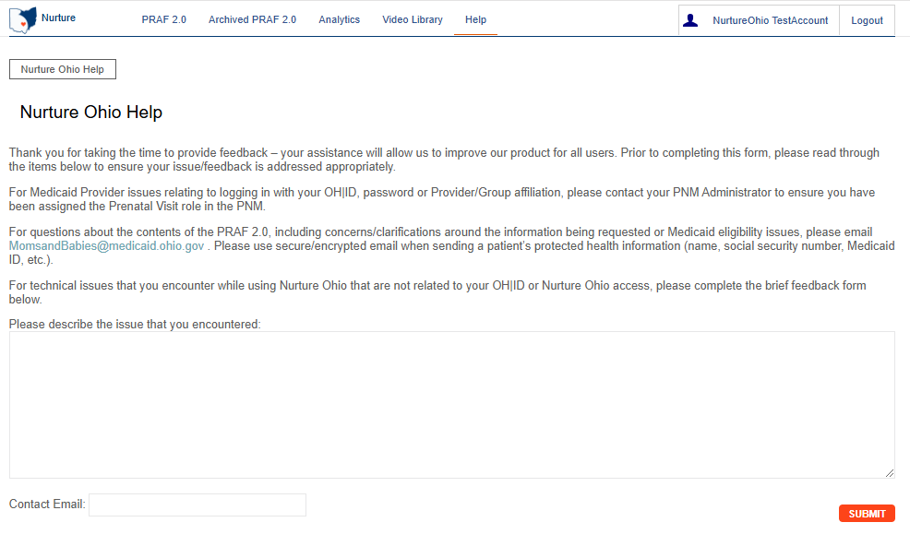
- Submit to helpdesk
Please Note: If you have any general questions regarding the PRAF form content or process, please email MomsandBabies@medicaid.ohio.gov with the Subject “PRAF Form”.

I Have a Question about the PNM module, OH|ID, or Portal Password Support

- Call the ODM Integrated Help Desk at (800) 686-1516, Representatives are available Mon - Fri 8 a.m. - 4:30 p.m.
- Email the ODM Integrated Help Desk at ihd@medicaid.ohio.gov
- Visit the OH|ID self-service portal at https://ohid.ohio.gov/wps/portal/gov/ohid/login

Maintenance and System Outages

If the Nurture system is shut down for maintenance, you will receive an e-mail from the Nurture Helpdesk (no-reply@duethealth.com). The Ohio Department of Medicaid paper-based notification process can be used during these system outages. The paper-based form, ODM 10207, and its accompanying instructions, ODM 10207i, can be found at the URL below.
http://medicaid.ohio.gov/RESOURCES/PUBLICATIONS/MEDICAIDFORMS.ASPX

Appendix A: About NurtureOhio Features

Shareable Data Entry
Multiple users associated with one practice can enter data on a patient’s form prior to final submission. The save feature lets one user begin a form and save it so that it can be completed later. Users can also edit a form up to 30 days after the original submission date.

One Time Data Entry of Practice and Provider Information
Clinics can set up practice and provider information so that it is readily available for all future uses. This reduces the amount of data entry needed to complete forms over time.

Same-Day Pregnancy Notification
Pregnancy notification helps patients maintain Medicaid eligibility. It also helps MCOs address the needs of pregnant Medicaid members more quickly.
The NurtureOhio website can notify the managed care plan and the Ohio Benefits Worker Portal of the patient’s pregnancy the same day it is entered into NurtureOhio. Practice users assist in this process by accurately entering the following patient information:
- First name
- Last name
- Date of birth
- Social security number (full 9 digits)
- Patient Medicaid ID/MCID
Ohio Benefits, Medicaid’s eligibility system, accepts pregnancy information directly from the information users enter in NurtureOhio. Accuracy of the five details above is important to match the individual’s case in Ohio Benefits. The patient Medicaid ID and/or the patient’s social security number are important as they are used to identify the member for whom pregnancy needs to be updated. The estimated pregnancy due date paired with the latter five identifiers are used to update the Ohio Benefits system. This helps prevent the loss of coverage during pregnancy. Please note the member ID number is consistent across Medicaid MCOs. The patient Medicaid ID will not always be the same as the MCO ID number which varies by insurance plan. Thus, please be sure to capture the patient Medicaid ID and not mistakenly input the MCO ID number. Below is where you will locate the patient Medicaid ID on our contracted managed care entity insurance cards.
The member ID # is:
- Used to verify a patient’s eligibility and their MCO,
- Consistent across all MCOs and Ohio Medicaid, and
- Required for the PRAF 2.0 form to communicate with Ohio Benefits.

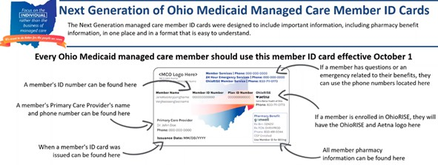
Below is where you will locate the member ID number on archived versions of the managed care organization cards.

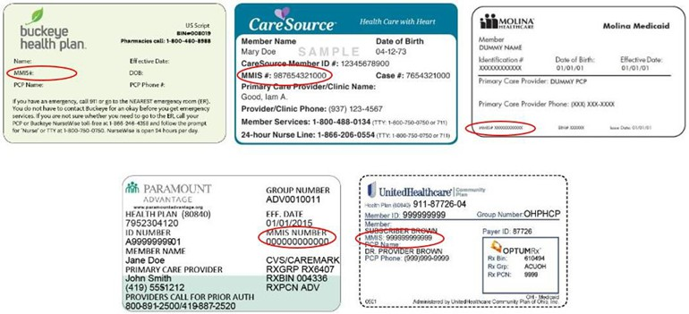

Ability to Retrieve and Save Previously Entered Forms
Forms entered can be viewed and downloaded in two different formats (PDF and CSV).
- Navigate to the “PRAF2.0 Submitted” tab
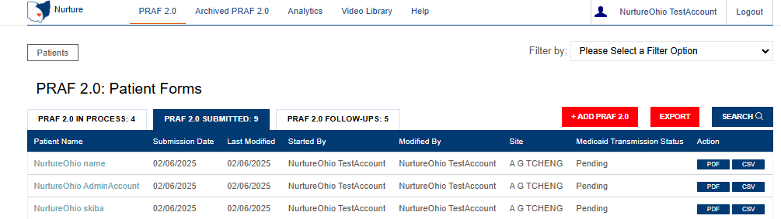
- After making your selection you can choose PDF or CSV under the Action heading to view or download forms

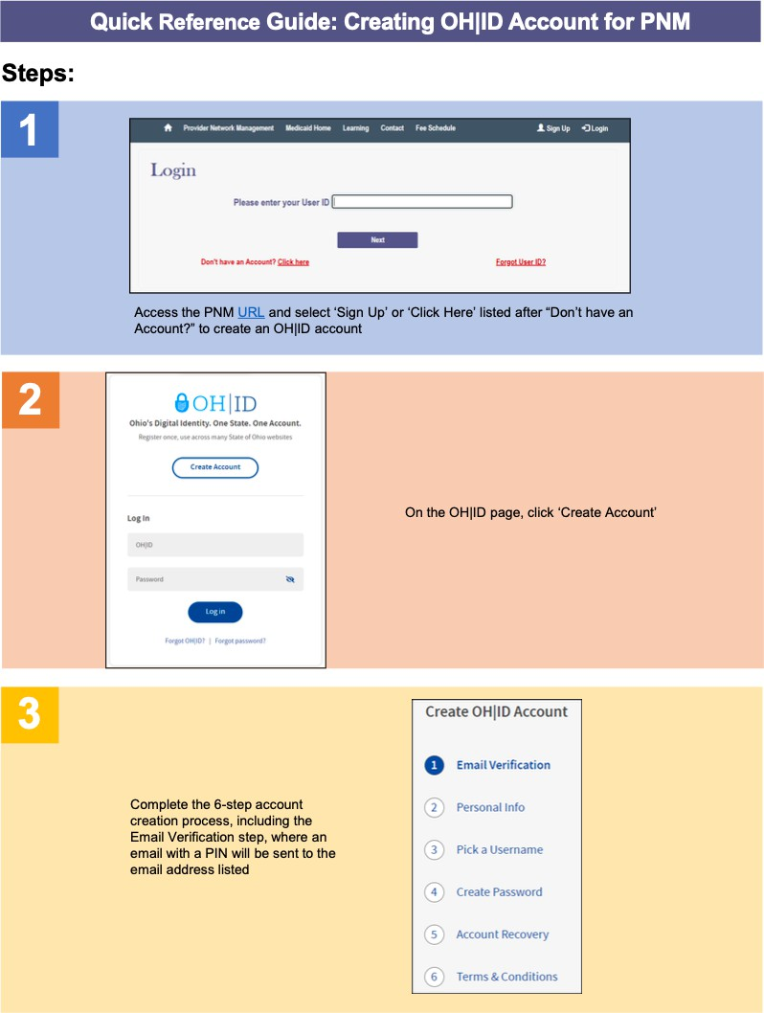
Appendix B: Creating an OH|ID Account for PNM as a Provider Agent
Note: Provider Administrators will need to call the integrated help desk after creating their OH|ID to complete registration within the PNM module.

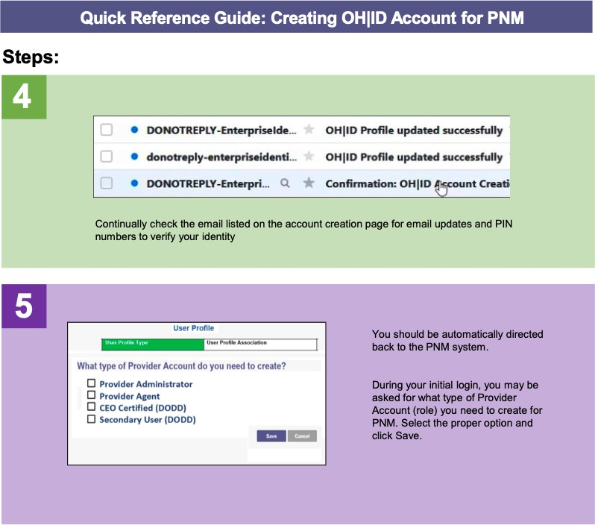

Appendix C: Adding Agent Roles in PNM
Steps:
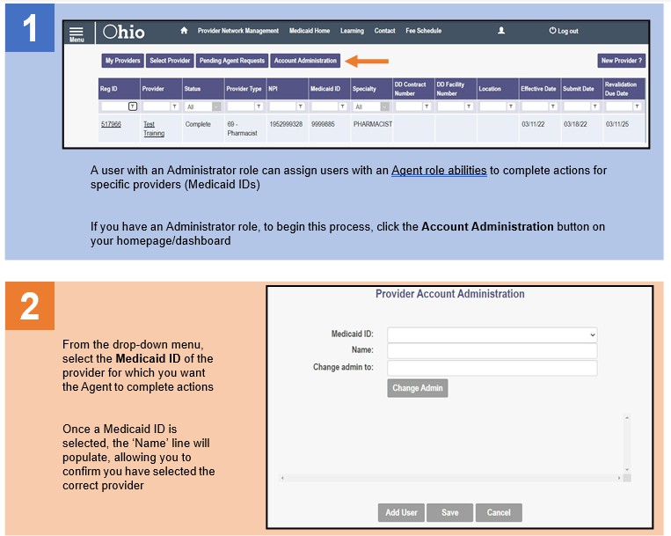
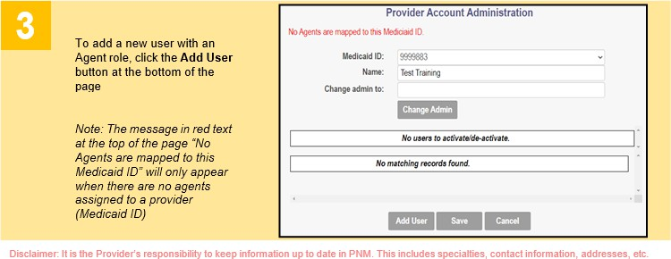

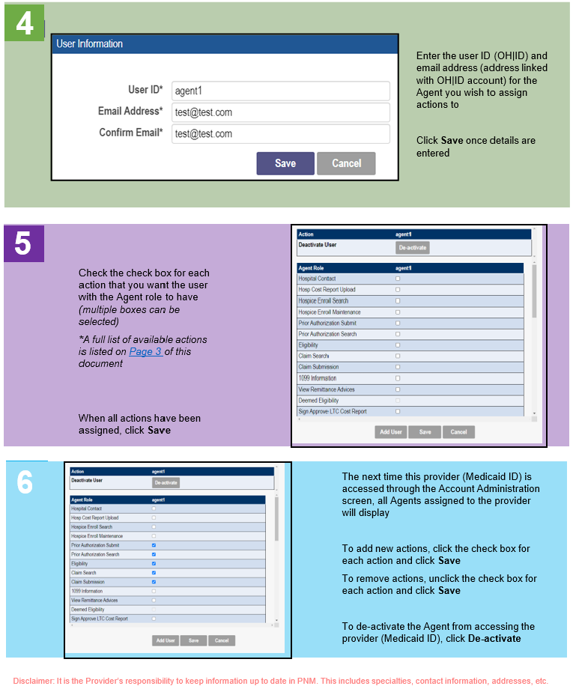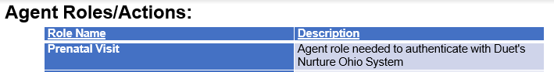

Appendix D: Patient Form Error Messages/Transmission Statuses

Error Messages

During Patient Validation the following error messages may be returned:

- Invalid/Missing Date(s) of Service-Verify Date of service is entered and valid
- Patient Date of Birth Does Not Match the Patient on File- Check for DOB accuracy
- Invalid/Missing Patient Medicaid ID-Verify that Medicaid ID is entered and valid
- Invalid/Missing Patient Name- Verify that patient name is entered and spelled correctly
- Patient Not Found-Verify all Patient information, and that patient has Medicaid
- Duplicate Patient ID Number-Verify that Medicaid ID is valid
- Must Provide Valid Patient Medicaid ID and/or Social Security Number-These are required fields; you must provide one accurately to move forward with completing PRAF
- Patient does not have active Medicaid coverage-PRAF submission is only for patients with active Medicaid coverage, please verify coverage
- System unable to respond, please contact NurtureOhio Helpdesk-Contact help desk for further guidance, can be caused by sitewide system issues.

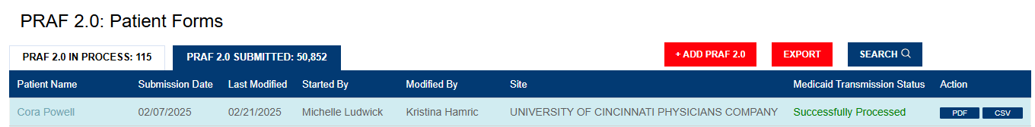
Medicaid Transmission Statuses
- Pending: Indicates the PRAF has yet to be processed. User does not need to take any further action.
- Successfully Processed:Indicates no errors, PRAF has been successfully processed. User does not need to take any further action.
- System Error: NurtureOhio to Resubmit, this is a system issue and NurtureOhio resubmits the following day. User does not need to take any further action.
- Processing Error: Please Contact Ohio Department of Medicaid. This indicates a "Multiple match return, record will be skipped." ODM will need to be contacted to investigate.
- Action Required: Click to edit form and resubmit. This indicates "No Match Found for Person in Ohio Benefits. Record will be skipped." This usually indicates that some identifiable member information is incorrect or doesn't match records (Check member name, SSN, Medicaid ID, and birthdate for accuracy). This requires user to update the PRAF and resubmit.
- Other Processing Error: Indicates any error that is not the above error codes.

